Senior Newsletter
November, 2018

Early decision and early action applications are mostly done, and we can all breathe a little before the next round of forms to fill out. Some of you still have more applications to finish. For some of you, your applications are finished, and now is the time to start looking for scholarships. Check the guidance page of the school website for links to scholarship searches; I recommend signing up for blog notifications from JLV College Counseling—she has weekly lists of scholarships from all kinds of organizations. My scholarship list is also on your Naviance account—on the main page scroll down and click on Document Resources and then click on the Scholarships document.

REMINDER!
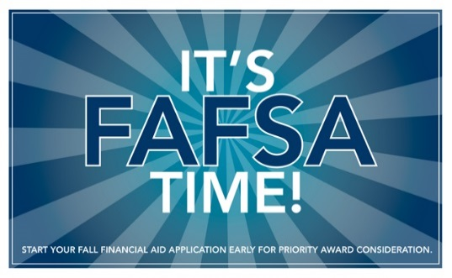
October 1st was the opening day for filing the FAFSA, the Free Application for Federal Student Aid. If you haven’t yet started on it, now is a good time to start. The FAFSA is the key to both federal and state aid, and even if your income is high enough to deny grant money, most students qualify for some amount of subsidized loans, which means lower interest rates.
Go to fafsa.gov to access the form; you can also find a FAFSA on the web worksheet here: https://studentaid.ed.gov/sa/sites/default/files/2017-18-fafsa-worksheet.pdf. Although you can’t mail it in, you can gather all the information you will need to make filling out the online form easier.
It is important to get the FAFSA done in a timely manner; Maryland and Virginia state deadlines are around the end of February. For both states, adding a possible state university is a good idea; even if you don’t plan on it, plans often change and you may want to have an option with state aid.

If you plan to attend Wor Wic and you are from Somerset County, be sure to follow the directions to qualify for the Somerset County Economic Implact Scholarship. The directions can be found at https://www.worwic.edu/Pay-For-College/Free-Community-College. The due date is June 1st, but it would be best to complete your Wor Wic application and the SEIS application by April. That way you can have early access to schedule your

Don’t let senioritis cause you problems! Keep your grades high and keep studying!
Don’t forget the Senior Project!!!! It is due the end of April and is worth 200 points on your fourth quarter English grade.
This Photo by Unknown Author is licensed under CC BY-NC-SA

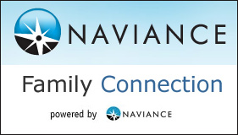
Don’t forget to update your Naviance College Applications page when you finish an application or when you hear a college decision. This is where I can see the status of your application and know if I need to send off your transcripts and other documents. Click on the pencil icon for the college, click on the box in front of the I have submitted my application and update the other information.

